7.61: a) For a friction force f, the total work done sliding down the pole is 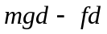. This is given as being equal to mgh, and solving for f gives
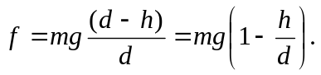
When 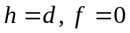, as expected, and when 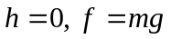; there is no net force on the fireman. b) 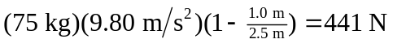. c) The net work done is 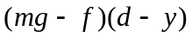, and this must be equal to 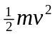. Using the above expression for f,

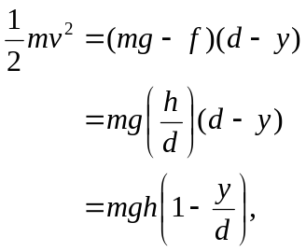

from which 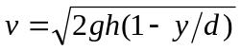. When 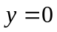 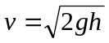, which is the original condition. When 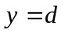, 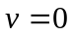; the fireman is at the top of the pole.

